**RCN MEDICAL MISSIONS REPORTING**

**Kaltungo, Gombe State**

5th, 6th and 7th April, 2025

1. **Background, team**

The RCN Missions’ Hospital was commissioned in year 2024 with its mission of providing affordable, accessible and high-quality healthcare, driven by love and guided by faith. The institution is devoted to delivering top-tier services that prioritize the physical, emotional and spiritual well-being of patients. The hospital is physically located in Makurdi Benue State, however, her reach extends beyond Makurdi to the far ends of Nigeria even reaching to distant and rural communities of the country. This is achieved through her three core programmes which include;

* + AromeCare (Medical Missions/Outreaches)
  + DinnaCare (Women and Children Health Support Programme)
  + DOCcare (Dedicated Organisation for Communities Care/Community Health Interventions)

The Medical Missions Team to Kaltungo, Gombe State

The Medical Missions team of the RCN Medical Center, under the umbrella of the Remnant Christian Network conducted free medical outreach at Kaltungo local government area of Gombe State, Nigeria. The team consisted of a Medical Doctor, Nurses, Medical lab Scientist, Pharmacy technician, Records officer and a logistic officer. The Medical Outreach to Kaltungo included a two-day outreach to members of the general community on the 5th and 7th of April as well as an outreach organized for the residents of the Palace of Kaltungo and people within the Palace’s surroundings on the 6th of April, 2025.

For the outreach to the general Kaltungo community which held at the Kaltungo Stadium, the team had healthcare workers from the community who volunteered for the outreach as well as members of the community who volunteered in areas like registration, crowd control and patient flow.

.

1. **Activities:** Pre-visit, visit, post-visit.
2. **Beneficiaries**

Residents of Kaltungo Local Government, Gombe State were the beneficiaries of the free medical outreach

1. **Aims / Goals**

Providing affordable, accessible and high-quality healthcare, driven by love and guided by faith is the core purpose of the RCN Medical Missions. The aim of the medical outreach was to provide health education, basic and essential health checks and screening, medical consultation services, basic medical interventions, counselling and medications for members of the community.

1. **Impact assessment** 
   1. Qualitative: During the medical crusade at the stadium, the people of Kaltungo local government area received health talk, they had their vital signs checked, there was a laboratory stand with equipment to provide free tests to people as required, the tests available included; Rapid Diagnostic test (RDT) for malaria parasite, test for Hepatitis B virus (HBsAg), test for Hepatitis C virus, blood sugar level test, widal test and RDT for HIV. All patients seen were given the opportunity to pass through the counselling station where they had access to spiritual and emotional care, counselling and prayers with adequate privacy ensured. Finally, the pharmacy provided the people with free medications as prescribed.

The medical outreach to the Mai Kaltungo's palace was a successful and impactful outing, in total, the team attended to 40 persons with 35 females and 5 males, age ranging from 8 years old to 80 years old. The people were all grateful for the extension of love.

One of the beneficiaries who happen to be the Tanttabara of Kaltungo and also an information officer of Kaltungo, Mrs. Talati S.kaburu on behalf of Kaltungo kingdom expressed appreciation for the medical care received. She mentioned that the people feel much gratitude that we considered to come to the palace with our benefits. She also mentioned that the medical team had come to not only provide physical care but also spiritual healing (through the crusade at the stadium) and they prayed that God bless RCN in return.

In response, the head of the medical missions team, Dr Dooyum also appreciated the Mai Kaltungo in absentia for opening the doors of the palace and accommodating the team and appreciated the Tanttabara of Kaltungo for her warm welcome and assistance.

* 1. Quantitative: Impact in Numbers (Demography and Health Statistics)

Stadium Day 1: 211 patients were attended to with females being 160 in number and males 51. The age of the participants ranged from 1 year to 84 years of age

Palace: 40 persons were attended to with females being 35 in number and males 5. The age of the participants ranged from 8 years to 75 years of age

Stadium Day 2: 267 patients were attended to with females being 215 and males 52.The age of the participants ranged from 5 months old to 88 years of age

1. **Accounting** 
   1. Amount spent on medical consumables
      1. Medications
      2. Laboratory Consumables
      3. General Consumables
   2. Amount spent on food/ items/ gifts
   3. Personelle remuneration
   4. Logistics and Transportation
   5. Preparation, Publicity and Reporting

|  |  |
| --- | --- |
| **FINANCIAL REPORT OF NORTH EAST MISSIONS 1st – 18th April 2025**  **(Bauchi, Kaltungo, Biu, Michika, Yola)** | |
| **ITEM** | **AMOUNT** |
| Vehicle arrangement ssss | 210,000 |
| Fuel | 284,158 |
| Lab | 419,500 |
| Pharmacy | 1,152,693.12 |
| Stipend @ 7 persons for 4 locations | 280,000 |
| Yola stipend/appreciation | 310,000 |
| Bauchi volunteers(12 persons) | 40,000 |
| Biu volunteers(2 persons) | 10,000 |
| Michika vounteers (5 persons) | 25,000 |
| Tp refund to Nr Sewuese & Diana | 25,000 |
| Feeding & accommodation | 250,000 |
| Finger batteries | 5,200 |
| HDL battery | 400 |
| Sellotape | 700 |
| Fixing of car plate number | 500 |
| Tollgate fee | 1,500 |
| Drinking water | 6,100 |
| Snacks & drinks | 21,500 |
| Black leather | 4,700 |
| Car repair | 5,000 |
| Bathroom slippers | 600 |
| Bikeman fare @ Biu | 1,000 |
| Car wash | 5,000 |
| Rim A4 paper | 6,000 |
| Mobil engine oil | 5,500 |
| Biros | 500 |
| Tyre /Jack/wheel spanner | 43,000 |
| Tyre replacement workmanship | 1,500 |
|  |  |
| **TOTAL** | **3.115,051.12** |
| **BALANCE with Dr. Dooyum** | **42,662.14** |

1. **Worth of services provided: (value assessment)** 
   1. Cost of drugs at 15% mark-up
   2. Prevailing cost of investigation services
   3. Cost of consultations at prevailing rate
   4. Cost of feeding
   5. Cost of gifts and other items
   6. Others
2. **Funding and Sponsorship**
3. **Medical Missions Vital? Summary Statistics** 
   1. **Number of clients seen**: A total number of 518 individuals were attended to
   2. **Biodemographic distribution**: All patients consented to receiving the free medical checks, consultation and free medication. The age of patients from the three days ranged from 5 months to 88 years of age. The 0-10 years age range children had the highest attendance of 91 (17.6%), followed by the 41 – 50 years age range with 78 (15.1%), the least represented age group was 71 years and above with 31 people (6%). Majority of the recipients of the medical outreach were females (78.9%).

Vital Signs: Temperature was checked for 408 persons, majority of them (58.6%) had temperature within the range of 36.6˚C – 37.5 ˚C, many of them (33.3%) had temperature within the range of 35.5˚C – 36.5˚C while few (8.1%) had above 37.5 ˚C. Pulse was checked for 396 persons with 90.9% having pulse rate within the range of 60-100 b/m, 7.1% had pulse rate above 100 b/m, while 2.0% had 50-59 b/m. Blood pressure was checked for 246 persons with 63.2% having blood pressure within the range of 90/60 – 130/90mmHg, 13.6% had above 150/90mmHg, 12.6% of them had blood pressure within the range of 131/90 – 140/90mmHg, 8.5% had blood pressure within the range of 141/90 – 150/90mmHg.

Lab Tests: Lab tests were done based on the consulting officer’s request. For blood sugar, in total, 45 persons had blood sugar checks with 37 persons (82.2%) having blood sugar levels within the range of 4.0 >7.8mmol/L, 7 persons (15.6%) had greater than 8.5mmol/L. For malaria tests, 36 persons were tested, 97.2% (35 people) of the tests were negative, 2.8% (1 person) was positive. Twenty-seven (27) people were tested for Hepatitis B, 92.6% were non-reactive, 7.4% (2 persons) were reactive. Twenty-seven (27) people were tested for Hepatitis C, 26 of them (96.3%) were non-reactive, 1 person (3.7%) was reactive. Five people had RVS test done and 60% (3 persons) were non-reactive, 40% (2 persons) were reactive. Widal test was not done for anyone at the Kaltungo medical outreach

* 1. **Disease Pattern (Diagnosis):** The most common diagnosis with 37.2% (192 people) was Dyspepsia followed by diagnoses of upper respiratory tract infection (URTI) reported in 104 people (20.2%), Malaria was reported in 77 people (9.1%), Hypertension in 49 people (9.5%), Enteric fever and vaginal candidiasis were both recorded for 33 persons (6.4%) each, while low back pain and myalgia were reported in 28 persons (5.4%) and 22 persons (4.3%) respectively. Osteoarthritis was diagnosed in 20 persons (3.9%), Pelvic Inflammatory Disease (PID) in 19 persons (3.7%), Gastroenteritis in 17 (3.3%) persons, and Urinary tract infection (UTI) and Dermatitis each diagnosed in 16 persons (3.1%).
  2. **Secondary Referrals**: Out of the 518 people attended to, 95 of them (18.4%) required secondary referral
  3. **Medications Prescribed**: The following medications were prescribed; tab paracetamol for 264 persons (51.2%), tab metronidazole for 174 persons (33.7%), Suspension gascol for 159 persons (30.8%), tab amoxicillin for 116 persons (22.5%), tab Omeprazole for 107 persons (20.7%), tab Ciprofloxacin for 83 persons (16.1%), tab gelusil (18.3%), Antimalarial tablets (16.6%), tab omeprazole (15.4%), tab diclofenac (12.9%), tab vitamin C (12.6%), tab ibuprofen (12.3%), tab amlodipine (10%), tab Lisinopril (9.7%), tab vitamin B-complex (9.7%),). Other medications prescribed include multivitamin tablets (5.1%), tab albendazole (5.1%), doxycycline capsules (5.1%), vasopinn (4%) cough syrup and expectorant (3.4%), tab piriton (3.1%), tab ampiclox (2.9%), tab prednisolone (2.3%), tab Augmentin (2.3%), syrup antibiotics and syrup non-steroidal anti-inflammatory drugs were also prescribed for pediatrics as well as other medications.

**LINKS TO GOOGLE FORMS**

Edit/summary page: <https://docs.google.com/forms/d/10atbQQzxLmM_m-oqDg43lrj8XhskpA7Zb8uLQi8xqXs/edit>

Responders’ link: <https://docs.google.com/forms/d/e/1FAIpQLSdGDhPkjPRAJ24BufRWbvwgwv9LeY1v_hZ2hBqs6isH62o-dg/viewform?usp=sha/;ring>

1. **Images and videos**

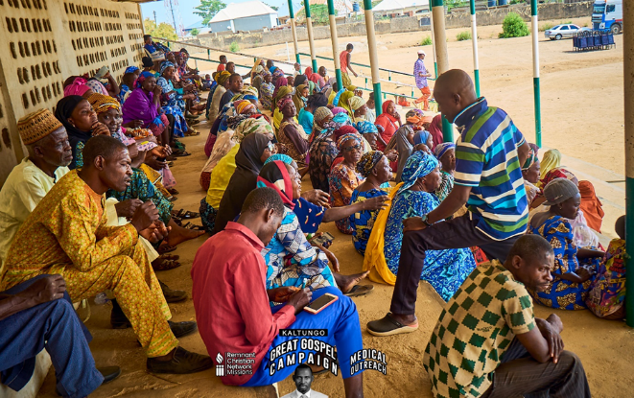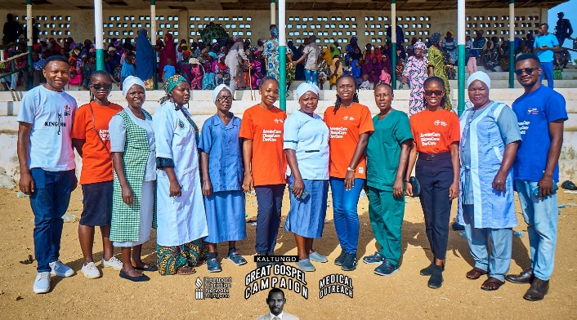**Gallery 1: At the Kaltungo Stadium**

**Members of Kaltungo community, Gombe State, seated at the grandstand of the Kaltungo Stadium to partake in the free medical outreach**

**Members of the RCN Medical Missions Team alongside healthcare volunteers from the community at the Kaltungo Stadium for Kaltungo Outreach**

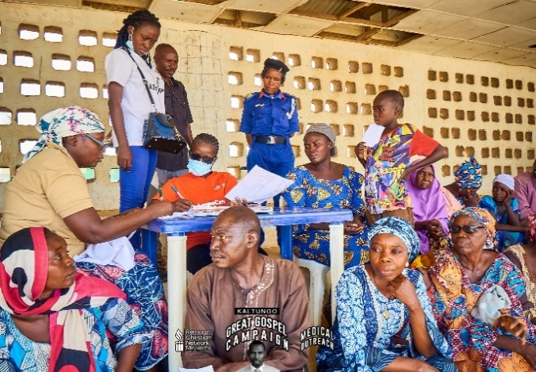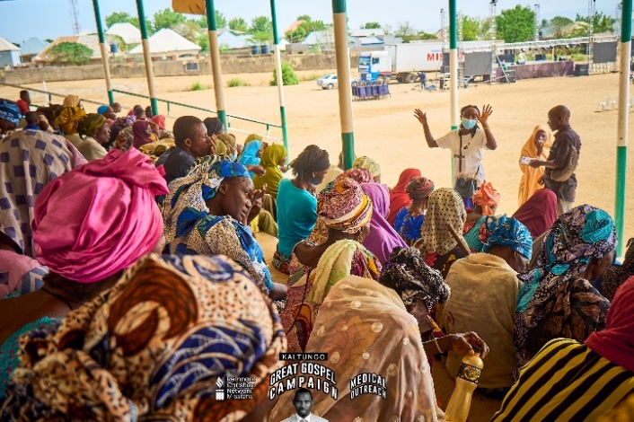

**Station 1: Registration desk**

**At the arrival lounge; Health Talk by Doctor Dooyum**

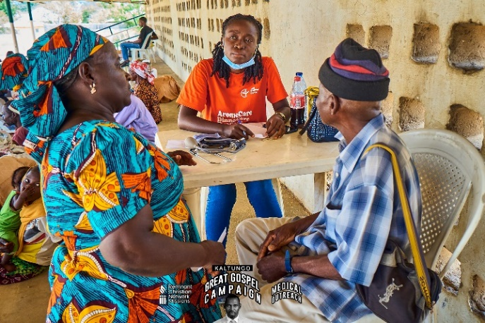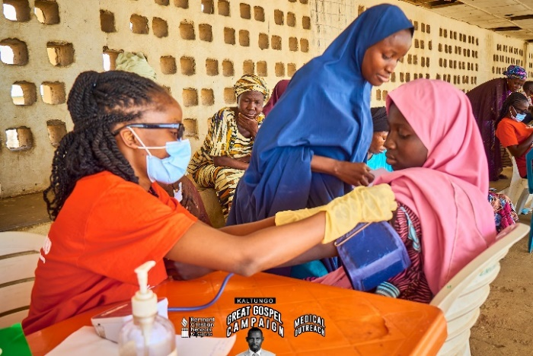

**Station 3: Consultation**

**Figure 1 Station 2: Vital signs checks**

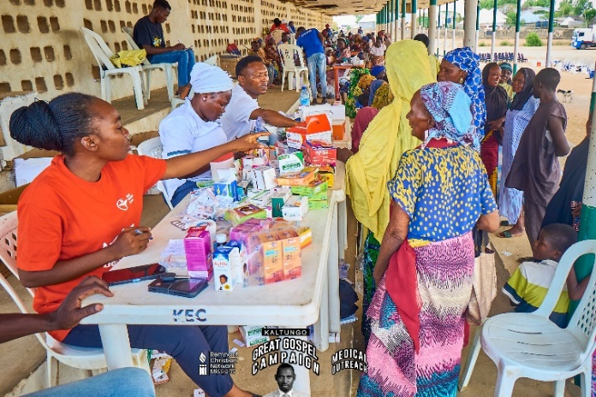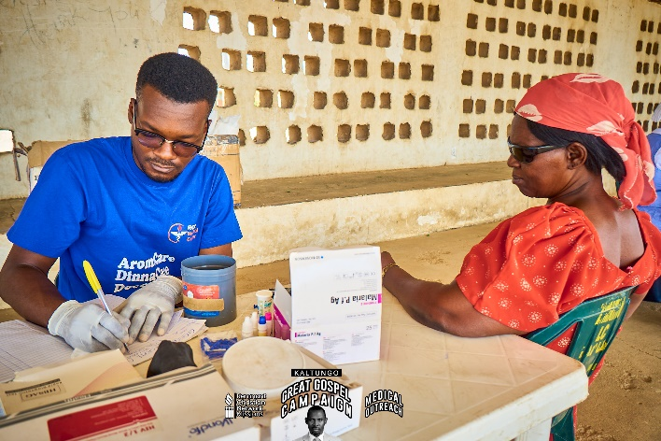

**Station 5: Pharmacy**

**Station 4: Medical Laboratory**

**Gallery 2: At the Palace**

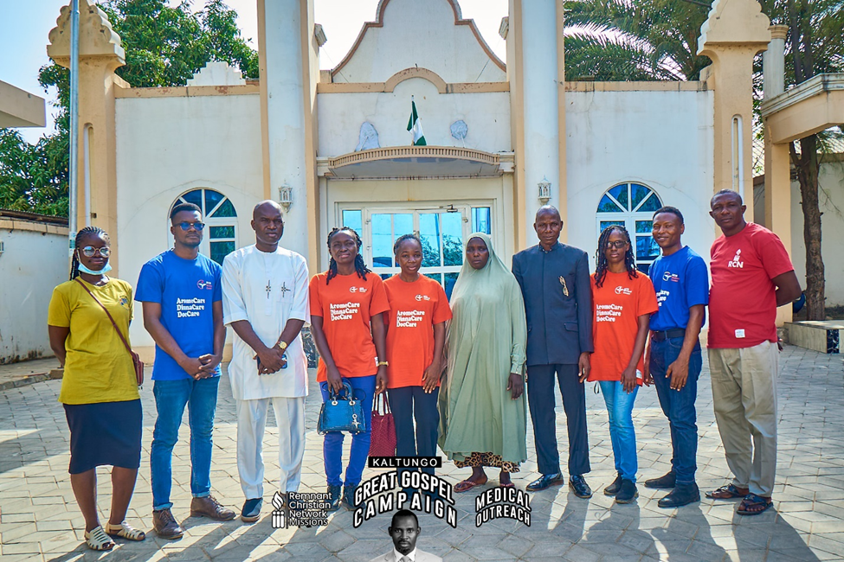

**Members of the medical missions team at the Mai Kaltungo's palace for a medical outreach to the**

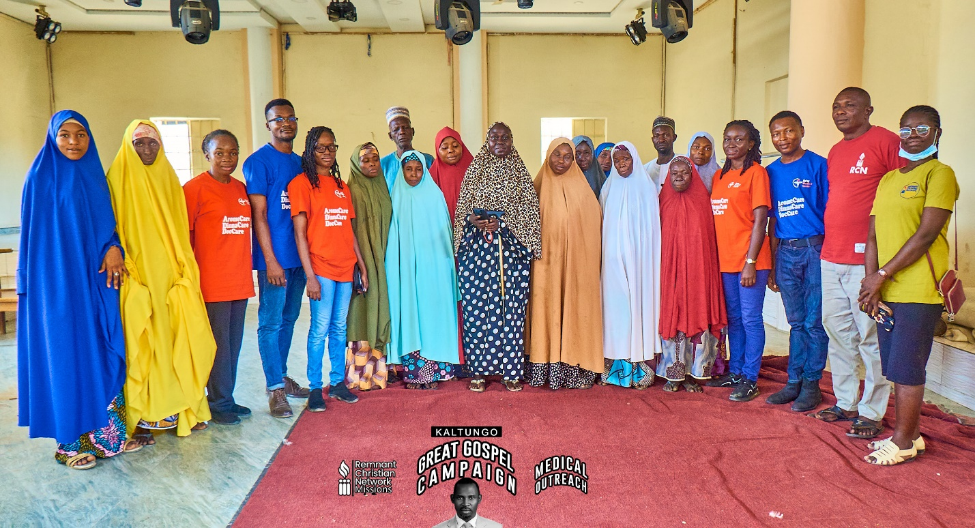

**RCN Medical Missions Team with the Tanttabara of Kaltungo (middle) and some of the beneficiaries of the free medical outreach at the Mai Kaltungo’s Palace after the outreach**

1. Copies of official permission
2. Strategic partnership agreements / proposals
3. **Observations, Recommendations and Follow-up visit Plans**

**Challenges Encountered**

1. Insufficient drugs, some attendees could not get some medications prescribed, while some had access to incomplete dose of medication and some were dissatisfied
2. Inadequate qualified practitioners. The medical team had only one Medical Doctor to consult for patients and there was no Pharmacist (Technicians and Nurses had to step in to assist)
3. There were slight issues of language barrier affecting proper communication with patients
4. Data collected on note cards piled up and this caused a delay in data analysis and reporting of results/findings.

**Observations**

1. Many of the indigenes, even including many of the children/adolescents had poor dentition. This could either be attributed to poor dental hygiene or to their source of water or another factor.

**Recommendations**

1. A medication list should be provided and basic medications that would be of high need should be procured.
2. Medication list should be made available for each consulting practitioner, to ensure that they prescribe things available
3. During pre-visit stage with weeks ahead of the outreach, medical practitioners should be contacted and a pool of possible available and qualified volunteers should be secured and constant communication should be made with them ahead of the upcoming outreach
4. Interpreters should be made available for stations needing them
5. Head of missions comment
6. Medical Director’s Comment and Signature.